Gujarat Council on Science & Technology
Dept. of Science & Technology, Govt. of Gujarat

Technical Report for Level-2 Proof of Concept (PoC) Stage for
ROBOFEST-GUJARAT 4.0

- Complete and exhaustive description of all the logical steps in the working of Robot

- Description of Robot

The maze solver robot is a compact and sophisticated device designed for autonomous navigation throughout the complex path. It features high-encoder motors (N20 encoder motor) with specified rpm and wheels that ensure smooth and agile movement. Equipped with advanced Time of Flight (TOF) sensors (VL53LOX, VL6180X), that effectively detect obstacles and walls by transmitting and receiving infrared rays, enabling it to navigate with precision. A dedicated motor driver (TB6612FNG) controls these motors, allowing for precise speed and direction adjustments based on real-time data received from the TOF sensors. At its core is a powerful microcontroller (STM32 Blue Pill) that processes data from these sensors and determines efficient routes based on the algorithm. The robot’s design and programmed algorithm allows the bot to explore the maze completely and find the shortest path to reach the target. Powered by rechargeable batteries, the robot is not only efficient but also environmentally friendly, making it ideal for extended exploration missions.

- Electronics Description

- STM Controller
The STM32 Blue Pill is a compact and versatile development board featuring the STM32F103 microcontroller from STMicroelectronics' STM32 family. Known for its affordability and robust capabilities

S. No | Specification | Details
1. | No of Cores | 1
2. | Architecture | 32 Bit
3. | CPU Frequency | 72 MHz
4. | RAM | 20 KB
5. | Flash | 64 KB
6. | GPIO Pins | 37
7. | Input Voltage | 3.3
8. | Output Voltage | 3.3 - 5 V

- Motor Driver
The TB6612FNG is a dual H-bridge motor driver IC designed for controlling DC motors and stepper motors in robotics and automation applications. Compact and efficient, this chip allows for bidirectional control of two motors simultaneously

S. No | Specification | Details
1. | Input voltage range | 2.5 - 3.5V
2. | Output voltage range | 2.5 - 13.5V
3. | Continuous output current | Up to 1.2A
4. | Peak current | Up to 3.2A
5. | Package type | 16 pin TSSOP
6. | Application | Suitable for varieties of motor
7. | Integration Advantage | Compact and space efficient design

- TOF Sensor:
The TOF VL53LOX and VL6180X is a time-of-flight (TOF) ranging sensor developed by STMicroelectronics, designed for precise distance measurement in various applications

S. No | Specification | Details
1. | Sensor Model | VL53L0X
2. | Operating range | 30mm - 2m
3. | Accuracy | 3% at 1m
4. | Supply Voltage | 2.8 - 3.6V
5. | Measurement mode | Proximity and ambient light

S. No | Specification | Details
1. | Sensor Model | VL6180X
2. | Operating range | 10mm - 100mm
3. | Accuracy | + 1 cm or -1 cm
4. | Supply Voltage | 2.8 - 3.6V
5. | Measurement mode | Proximity and ambient light

- Encoder Motors:
The N20 encoder motor is a compact and versatile DC motor equipped with an integrated rotary encoder, making it ideal for precision applications in robotics, automation projects
This motor operates within a voltage range of 3V, providing a good balance of speed and torque. The built-in encoder generates feedback signals, allowing for accurate measurement of rotational position and speed.

S. No | Specification | Details
1. | Type | DC Gear Motor with Encoder
2. | Voltage rating | 6V
3. | Encoder Resolution | 20 pulses per revolution
4. | Shaft Diameter | 3mm
5. | Stall torque | 0.5 kg-cm (varies with load)

- Printed Circuit Board (PCB)

The Printed Circuit Board (PCB) is a crucial component that integrates and organizes various electronic elements, ensuring efficient communication and power distribution. Typically, the PCB houses the microcontroller, which processes data from sensors and controls the motor functions, creating a streamlined design that minimizes connection errors.

Its compact design reduces space usage and weight, enhancing the robot's agility while allowing for easier integration into the overall chassis. The PCB also features headers or connectors for interfacing with additional components, such as batteries or communication modules, providing modularity for upgrades and modifications.

- Features

- Autonomous Navigation
- Short Path Detector
- Real-time data Processing
- Obstacle Avoidance
- Advanced Mapping Techniques

- Complete and exhaustive listing of all the hardware / component / equipment (electronics and mechanical)

- Electronics component

- Electronics Modules
S.NO | COMPONENT | VISUAL REPRESENTATION
1. | STM 32 | 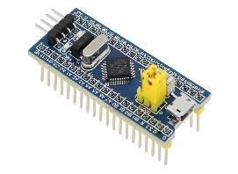
2. | VL53L0X | 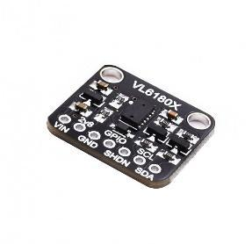
3. | VL6180X | 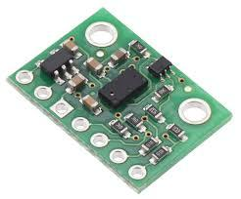
4. | MOTOR DRIVER(TB6612FNG) | 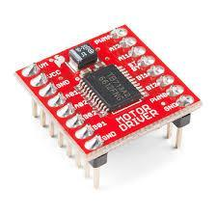
5. | ST LINK | 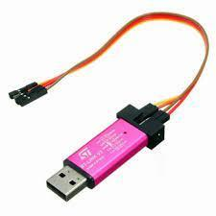

- Electronics Components Used for Fabrication
COMPONENT  NAME | ROLE | VISUAL REPRESENTATION
Soldering station | - Soldering station is used to fix all the components in the printed circuit board with the help of soldering lead. | 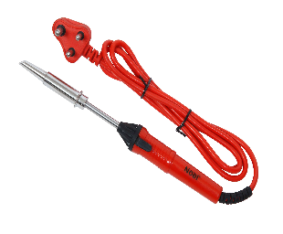
Soldering lead | - Soldering lead used to solder the components in the board. | 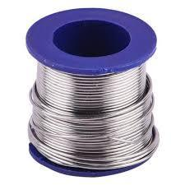
PCB  (Printed Circuit Board) | - The Printed Circuit Board acts as a base of the maze solver robot  .  - It provides a solid Mechanical base for mounting and supporting the electronics components like STM32, Motor driver, encoder motors, sensors. | 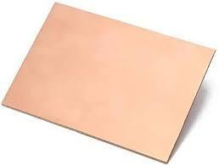
Dot Board | - A dot board is a versatile prototyping tool that enables engineers and hobbyists to create and test electronic circuits quickly and efficiently.  - Its grid of holes allows for easy insertion of components and wiring, facilitating flexible circuit configurations without soldering | 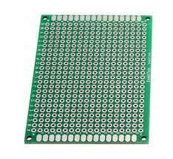

- Tools, Equipment Used.
Bread Board | A breadboard is an essential prototyping tool that allows engineers and hobbyists to build and test electronic circuits without soldering, facilitating quick modifications and iterations. | 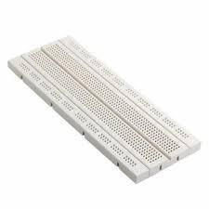
Multimeter | A multimeter is a vital diagnostic tool used in electronics to measure voltage, current, and resistance, providing crucial insights into circuit performance and functionality. | 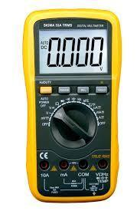

- Mechanical Components
- Mechanical Modules
COMPONENT  NAME | DESCRIPTION | VISUAL REPRESENTATION
Encoder Motors | - The encoder motor is essential for giving the bot exact control over its movement and speed.  - It aids in PID alignment and the bot's turning. | 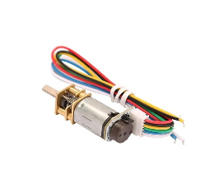
N20 Wheels | - The robot that solves mazes uses the N20 wheels as its propulsion mechanism.  - The robot's path through the labyrinth. | 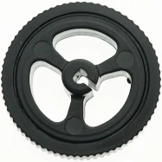
N20 caster wheel | - Caster wheels are typically placed at the front or rear of a robot to provide pivoting support. | 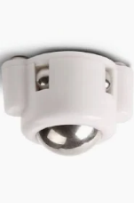
Mounting bracket | - The mounting bracket and screws are used to attach the motor to the PCB | 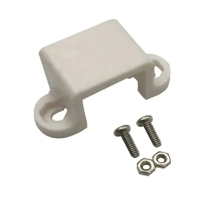

- Tools, Equipment Used
Screwdriver box | A screwdriver box is a compact storage case designed to organize and hold various screwdriver heads and handles. | 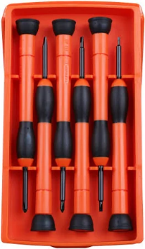

- Electromechanical Component
Lithium polymer battery | - A lithium-polymer (LiPo) rechargeable battery is a lightweight, high-energy-density power source  - It provides stable voltage output and can be shaped to fit various device designs. | 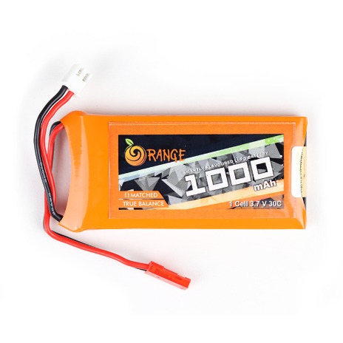

- Complete and exhaustive listing of all the software used in Robo-making

- Software Used

- ALTIUM
Altium Designer is a powerful PCB design software essential for developing maze solver robots, offering a comprehensive suite of tools to streamline the design process. Its intuitive interface allows engineers to create detailed schematics and complex circuit layouts while integrating various components like sensors, motors, and microcontrollers.
Key features include advanced routing capabilities, such as interactive routing and auto-router functionality, which optimize layouts for size and performance. The software includes robust design rule checking (DRC) to identify potential manufacturing issues, reducing errors. With its 3D visualization feature, users can assess component placement and wiring space effectively.
Altium also facilitates collaboration through project management tools and version control, enhancing teamwork. Additionally, it generates critical manufacturing outputs, such as Gerber files and bills of materials (BOM), ensuring a smooth transition from design to production. Overall, Altium Designer improves the efficiency and accuracy of maze solver robot projects.

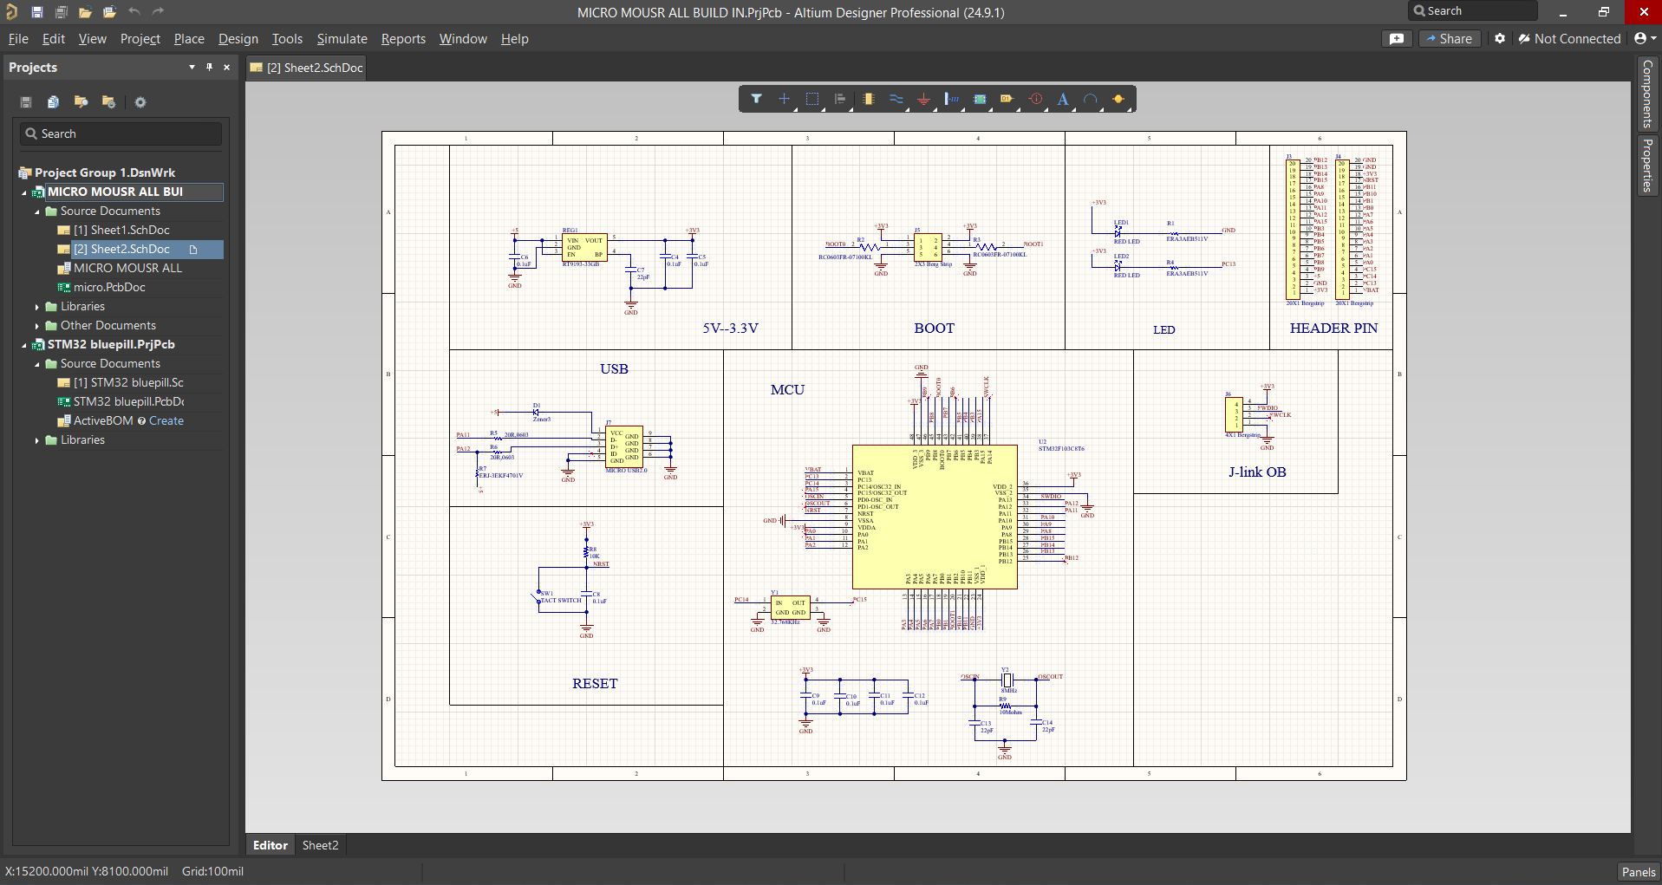
Figure 1.1 Schematic Design in Altiun
- ARDUINO IDE

The Arduino IDE (Integrated Development Environment) is a powerful and user-friendly platform designed for programming Arduino boards, making it ideal for projects like maze solver robots. Its simple interface caters to both beginners and experienced developers, featuring syntax highlighting and code auto-completion to enhance the coding experience. With extensive library support, users can easily integrate components like sensors and motors, speeding up development.
Cross-platform compatible with Windows, macOS, and Linux, the Arduino IDE allows coding and uploading on various operating systems. The built-in serial monitor enables real-time communication with the Arduino board, aiding in debugging and monitoring during operation. Supported by a vast community offering documentation, tutorials, and forums, the Arduino IDE simplifies the coding, testing, and optimization of navigation algorithms for robotics projects. Overall, it is an essential tool for developing maze solver robots efficiently.

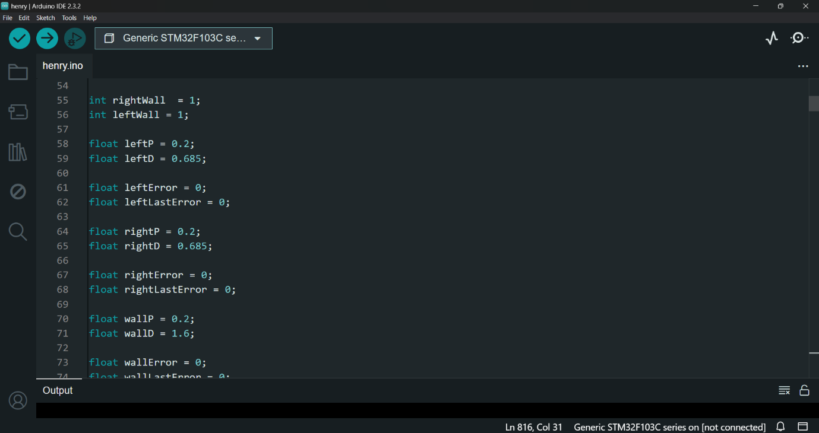
Figure 1.2 Bot Coding
- SOLID WORKS:

SolidWorks is a leading computer-aided design (CAD) software developed by Dassault Systems, widely utilized in engineering and manufacturing for 3D modeling, simulation, and product design. It enables users to create detailed 3D models of parts and assemblies with a parametric design feature that automatically updates related dimensions when changes are made. The software also includes robust simulation tools, allowing for testing under real-world conditions, such as stress analysis and motion dynamics. Additionally, SolidWorks facilitates the generation of 2D drawings from 3D models, making it easier to create technical documentation. With its ability to manage complex assemblies, collaborate through cloud services, and customize functionalities with add-ins and macros, SolidWorks is essential for professionals across various industries, including aerospace, automotive, and consumer products. Its user-friendly interface makes it accessible to both beginners and experienced users, providing the necessary tools to transform innovative ideas into tangible designs.

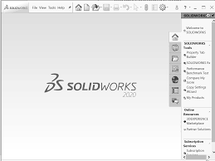

Figure 1.3 Designing in Solid works

- DIPTRACE
Dip Trace is a versatile PCB design software suitable for both novice and experienced engineers, making it ideal for projects like maze solver robots. It provides a comprehensive suite of tools for schematic capture, PCB layout, and manufacturing output, streamlining the design process. The user-friendly interface allows easy creation and editing of schematics with a vast library of symbols and footprints.
Supporting multi-layer designs, Dip Trace features powerful routing tools, including auto-routing and manual routing, along with design rule checking (DRC) to ensure compliance with standards. Its 3D visualization capability enables users to identify potential issues with component placement before manufacturing. Dip Trace also generates essential manufacturing files, such as Gerber files and bills of materials (BOM), simplifying the transition from design to production. With robust import and export capabilities, it integrates seamlessly with other design tools, making it a valuable asset for creating PCBs for maze solver robots and other electronic projects.

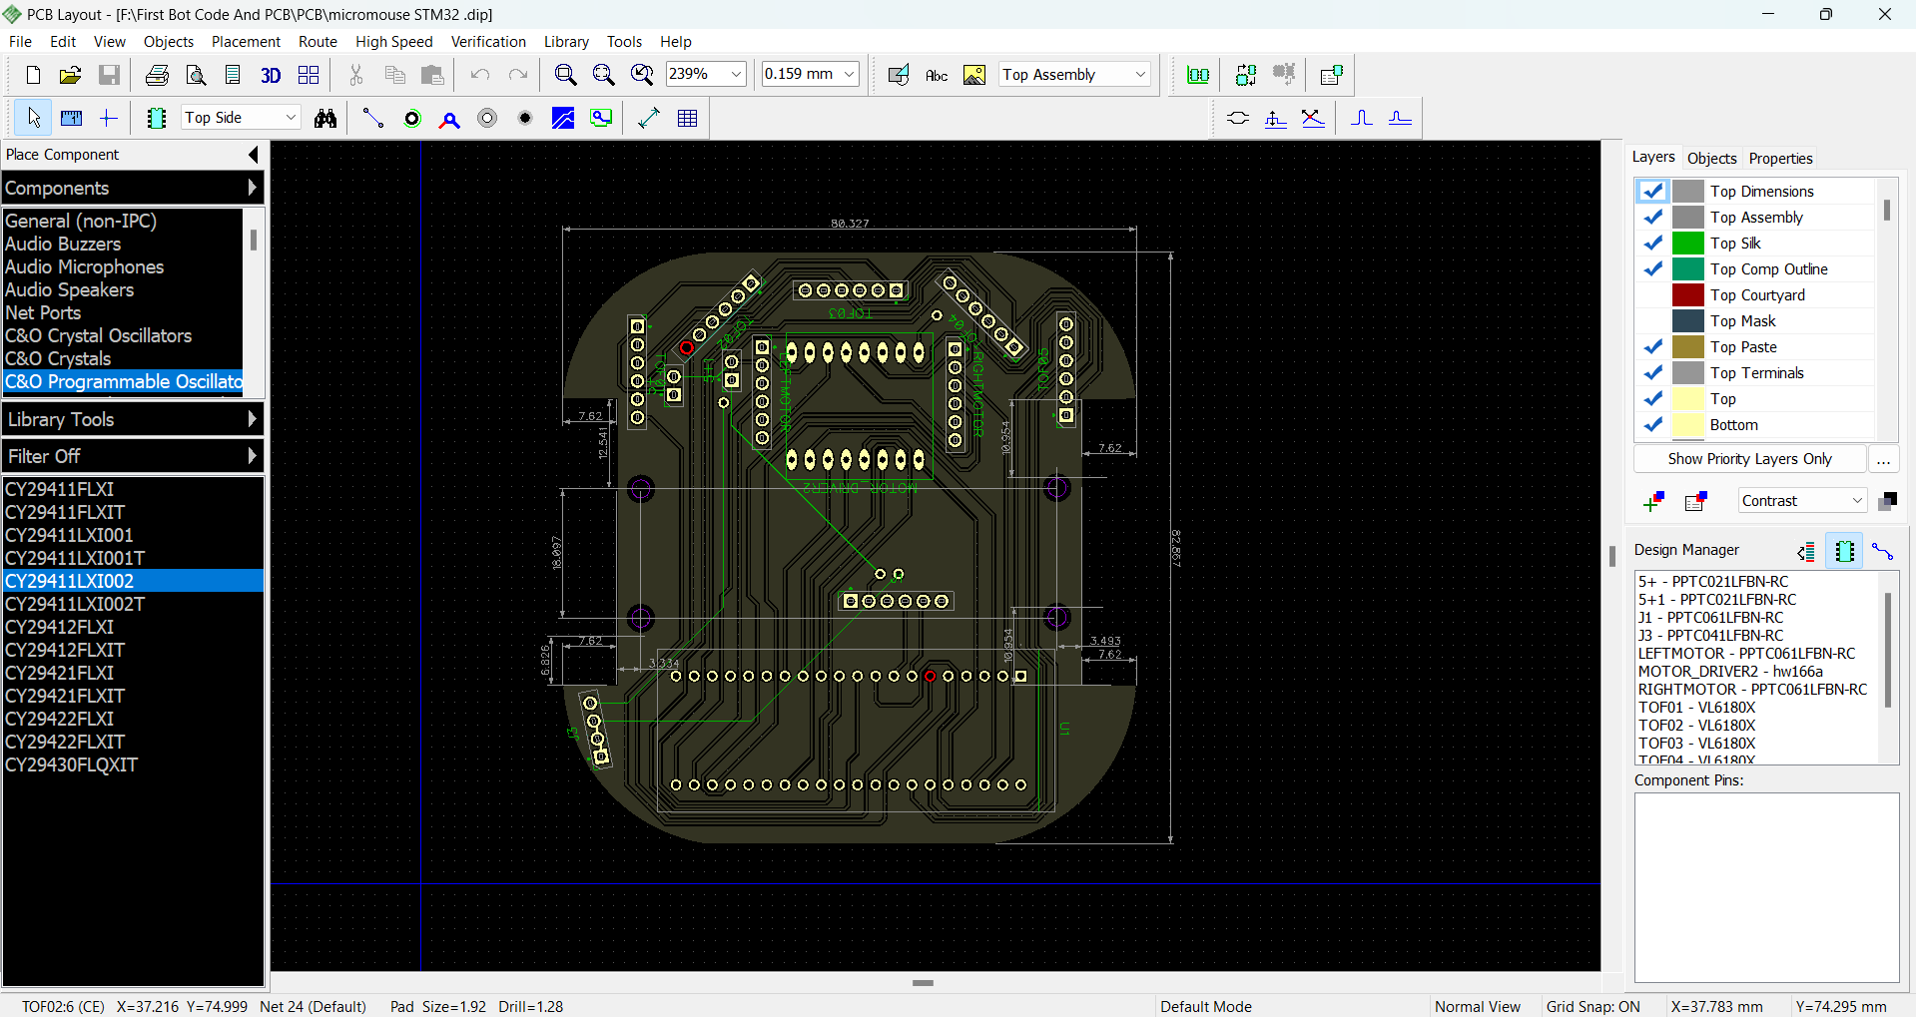
Figure 1.4 Single layer routing in diptrace

- Software Developed
- Flood Fill Algorithm

The mouse uses a modified flood fill algorithm to scan the physical maze. How a typical flood fill algorithm works is it scans all possible directions from the current cell, and then recurses down each of the cells that are able to be visited, until every cell has been visited. This is the behavior of the typical flood fill. In terms of the micromouse however, this algorithm is not satisfactory, since the mouse needs to physically move throughout the maze. With the described algorithm, the mouse would be expected to teleport back to previous cells, as well as already knowing the maze. We needed to modify this algorithm so that the wall-checking instead uses scanner distances to check for immediate walls, as well as consider mouse movement and directions, and moving the mouse to previous cells during recursion. In our implementation, we create a 2d array of the maze and use it to keep track of the north, east, south, and west walls, as well as if the related cell has been visited.
The micromouse navigates the maze by tracking the decreasing values in a 2D array that represents the maze layout. Starting from a corner cell with the highest value, it aims to move toward the center cell at (0,0), which has the lowest value. When the micromouse identifies a cell with a value of 14, it will seek to move to an adjacent cell with a value of 13. If multiple options are available, such as two cells both showing a value of 13, the mouse will rely on its sensors to detect walls in those directions. It prioritizes moving toward the direction that has no wall (indicated by the sensor readings), ensuring that it can proceed without obstruction. By combining the 2D array values with real-time sensor data, the micromouse effectively decides its path based on both the decreasing values and the immediate environment. This approach allows it to navigate efficiently through the maze while avoiding walls and obstacles, ultimately aiming to reach the center cell.

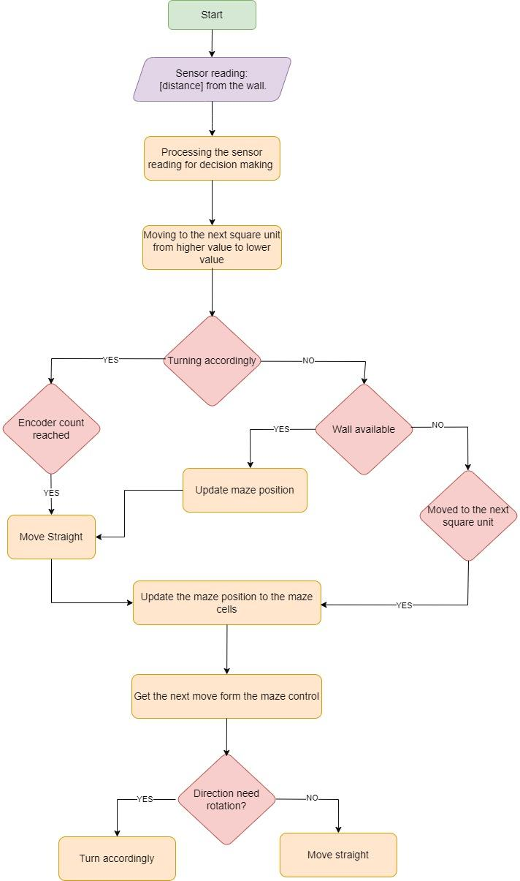
Figure 2.1 Flow of Algorithm
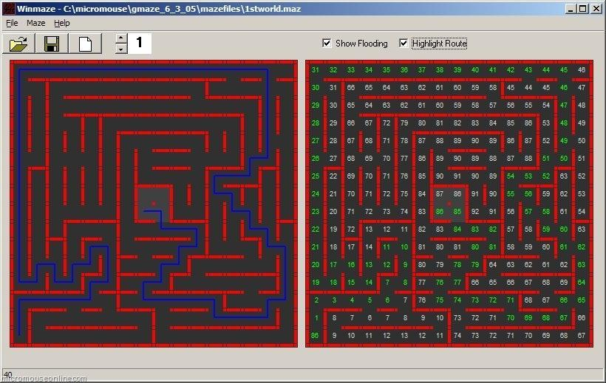
Figure 2.2 Virtual Maze Solving
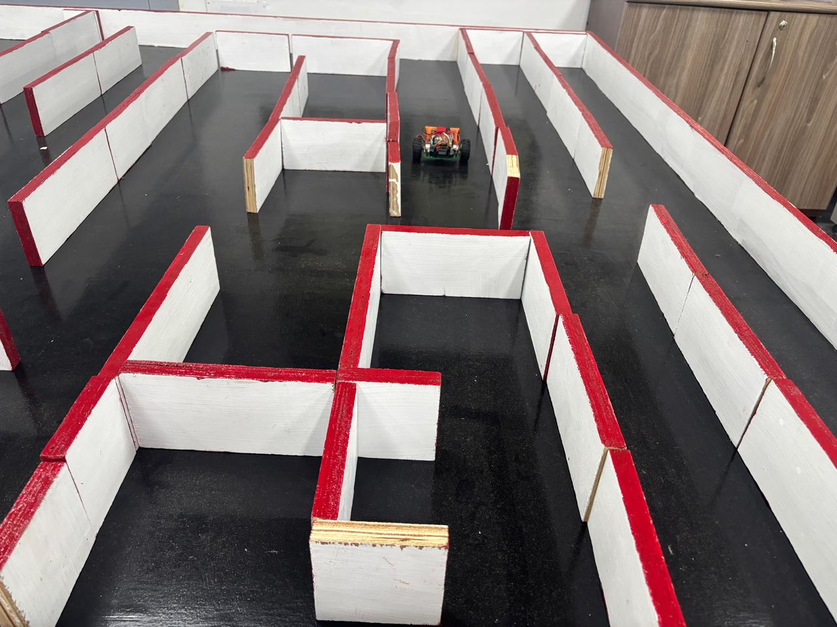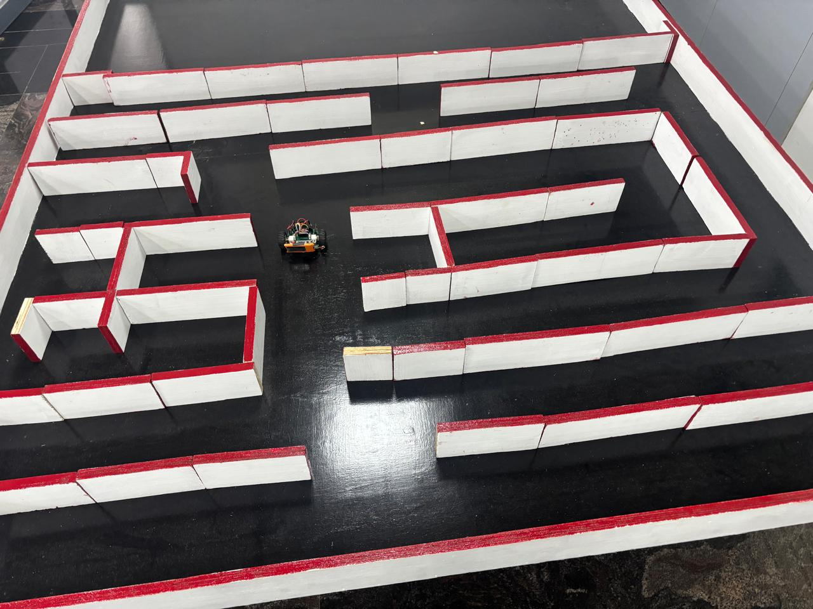

Figure 2.3 Real Maze Solving
- Wall Follow Algorithm

The wall-following algorithm guides a robot through a maze by leveraging the presence of walls. Initially, the robot assumes no walls except for the maze boundaries. As it navigates, it detects walls to its right, left, and front, with the primary goal of following the right wall. It makes a right turn whenever possible to stay adjacent to the wall. If the robot encounters a corner or a dead end, it will perform an about-turn to face the opposite direction and then resume following the wall. The robot prioritizes movements based on wall proximity: it will turn right if there’s no wall (value of 0) on the right. If the right is blocked (value of 1) but both straight and left paths are clear (values of 0), it will move straight. It will turn left only if both right and straight paths are blocked, and if all paths are blocked, the robot will perform an about-turn to find a new route. This systematic approach enables effective exploration of complex mazes.
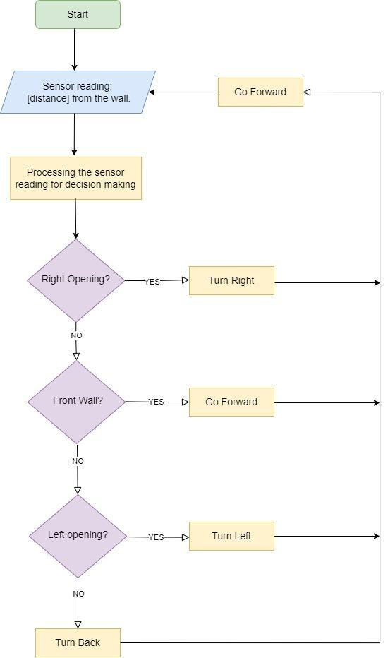
Figure 2.5 Flow of Wall Follower Algorithm

- Proportional Integral Derivative (PID):

PID control, or Proportional-Integral-Derivative control, is a key algorithm used in micro mouse robots to enhance navigation through mazes. It consists of three components:
Proportional control (P) calculates the error, which is the difference between the desired position and the current position, generating output proportional to this error. This allows for quick corrective actions when the robot veers off course.
The Integral control (I) addresses cumulative past errors, eliminating steady- state offsets, which helps maintain accurate navigation even under consistent biases. If the robot drifts due to uneven surfaces, this component adjusts the steering to correct the deviation over time.
The Derivative control (D) predicts future errors based on the rate of change, helping to dampen the response and minimize overshooting, particularly during sharp turns. By continuously processing data from sensors, the PID controller dynamically adjusts the robot's motor speeds and directions.
Overall, PID control significantly improves the robot's accuracy, responsiveness, and adaptability, making it essential for effective maze-solving in competitive environments. Proper tuning of the PID parameters can optimize performance based on specific maze characteristics.

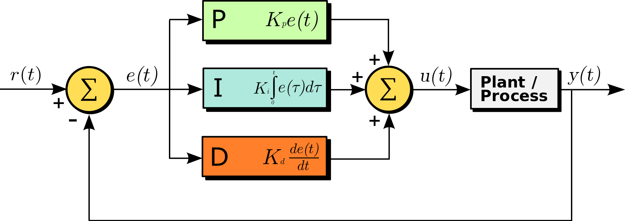
Figure 2.6 Structure of PID Control

- Additional Features in Actual Robot-Making
- Gyroscope Sensor for more accuracy in PID control
- Inbuilt Microcontroller in PCB for more compactness

- Concurrence / Deviation from Level1 document with reasoning

Deviation: The single layer PCB is updated into double layer.
Reason: To reduce the complexity in design and routing.

- Any Other description not mentioned above

- Project workflow:

This flowchart illustrates the bot creation process, divided into three phases:

1. Pre-work: Define objectives, conduct research, and components selection.

2. Bot Making: Circuit and PCB designing, assemble and test the bot, and integrate with the software.

3.Post-work: Customize the bot, document the process, present the project, and plan for future improvements.
It provides a clear overview from initial planning to final presentation and future planning.
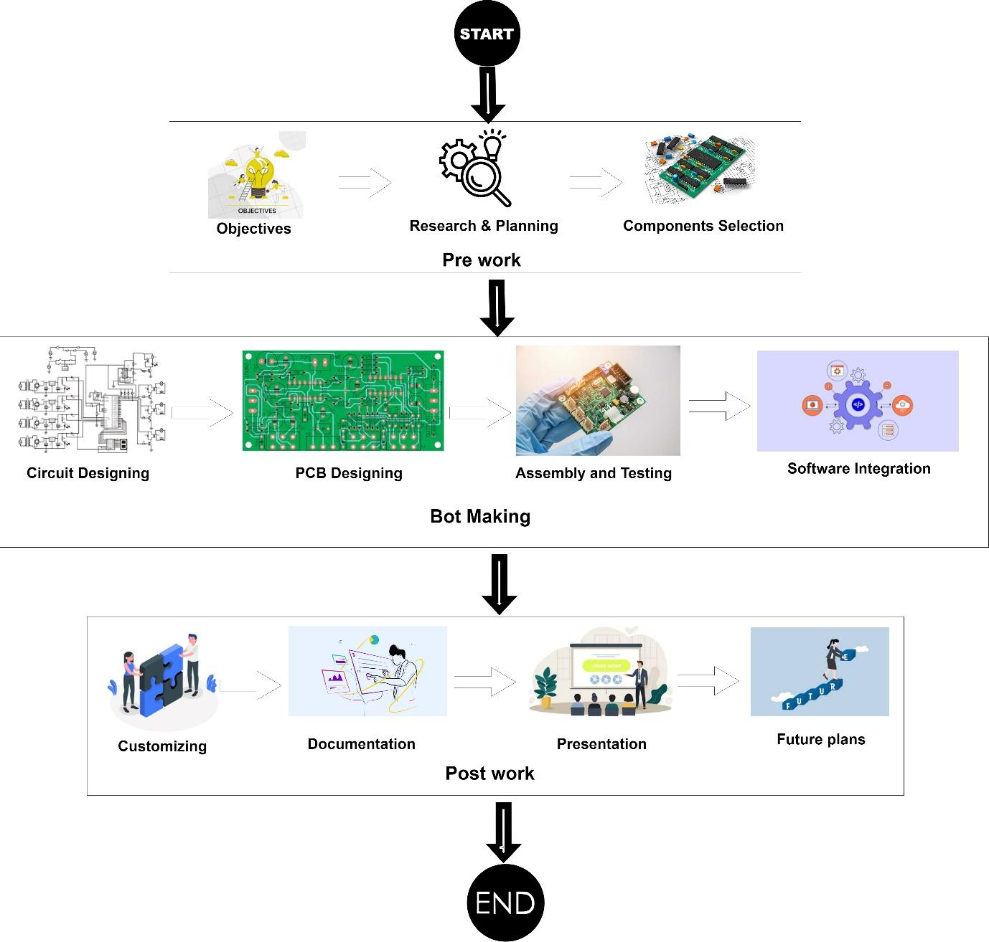

Figure 3.1 Workflow of Robot Making

- PCB Designing:
- Circuit Designing:

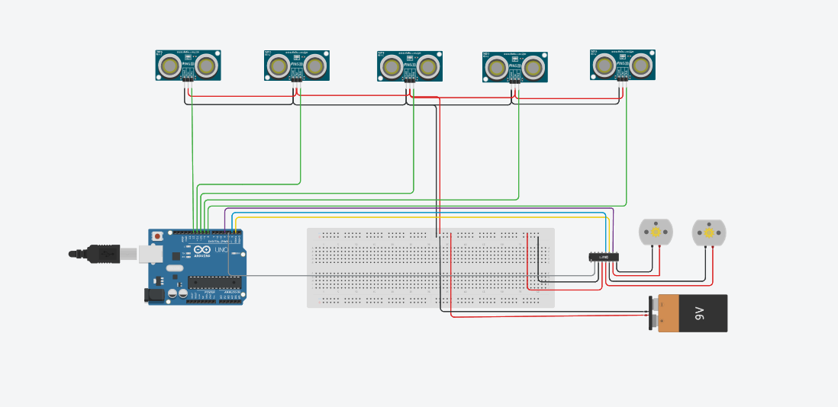
Figure 3.2 Circuit Designing

- SCHEMATIC DESIGNING

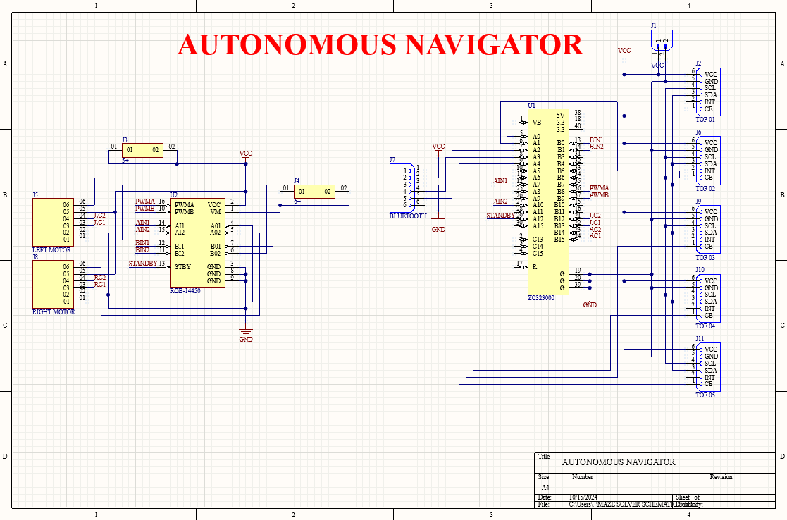
Figure 3.3 Schematic design

- LAYOUT DESIGNING
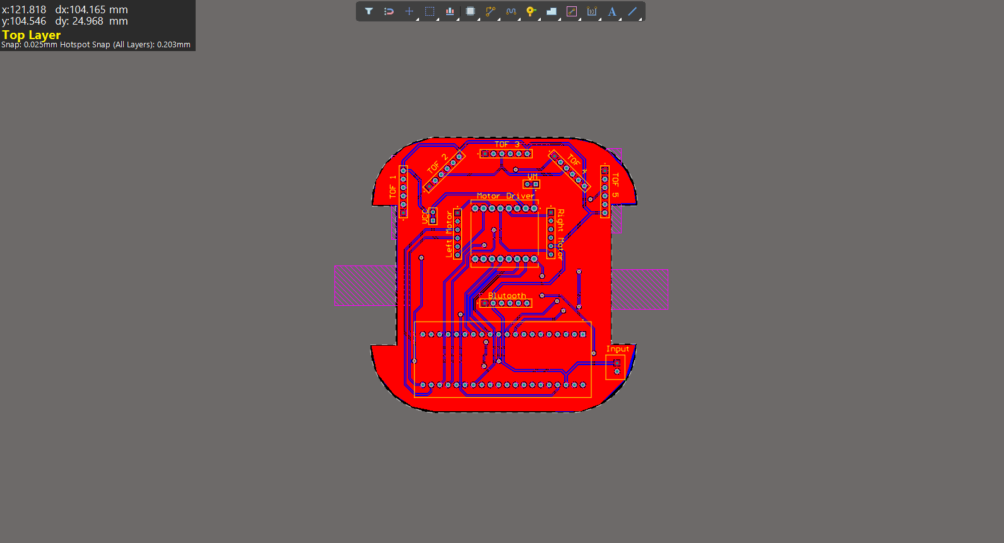
Figure 3.4 Top View
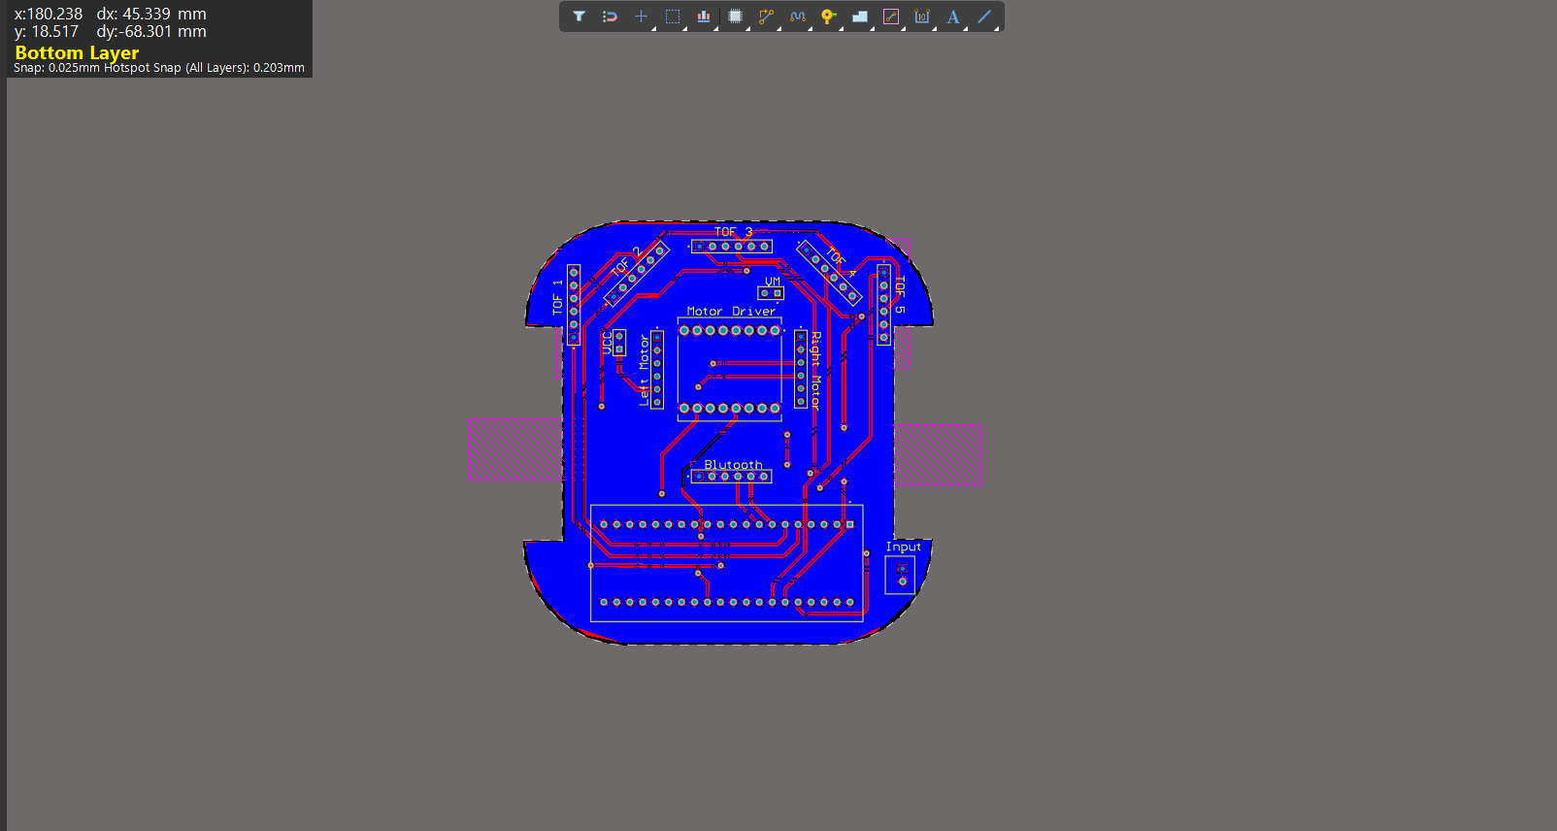
Figure 3.5 Bottom View

- Double Layer:
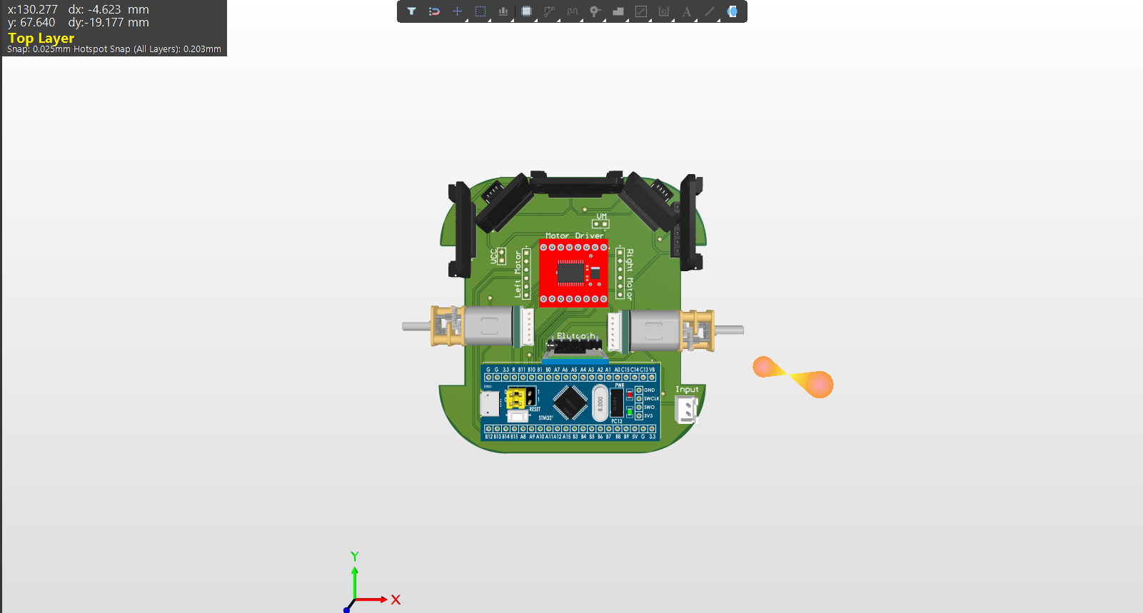

Figure 3.6 3D View of Double layer

- ASSEMBLING AND TESTING
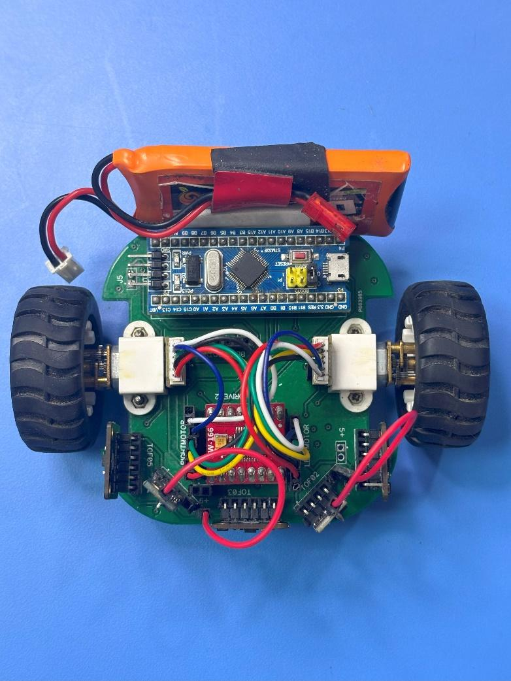
Figure 3.6 Assembled bot

- Photos of Robot-Making

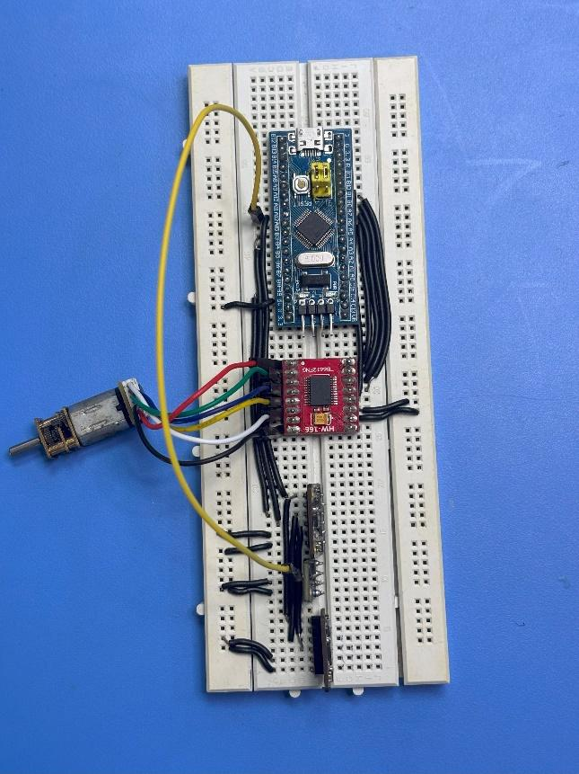
Figure 4.1 Breadboard Design

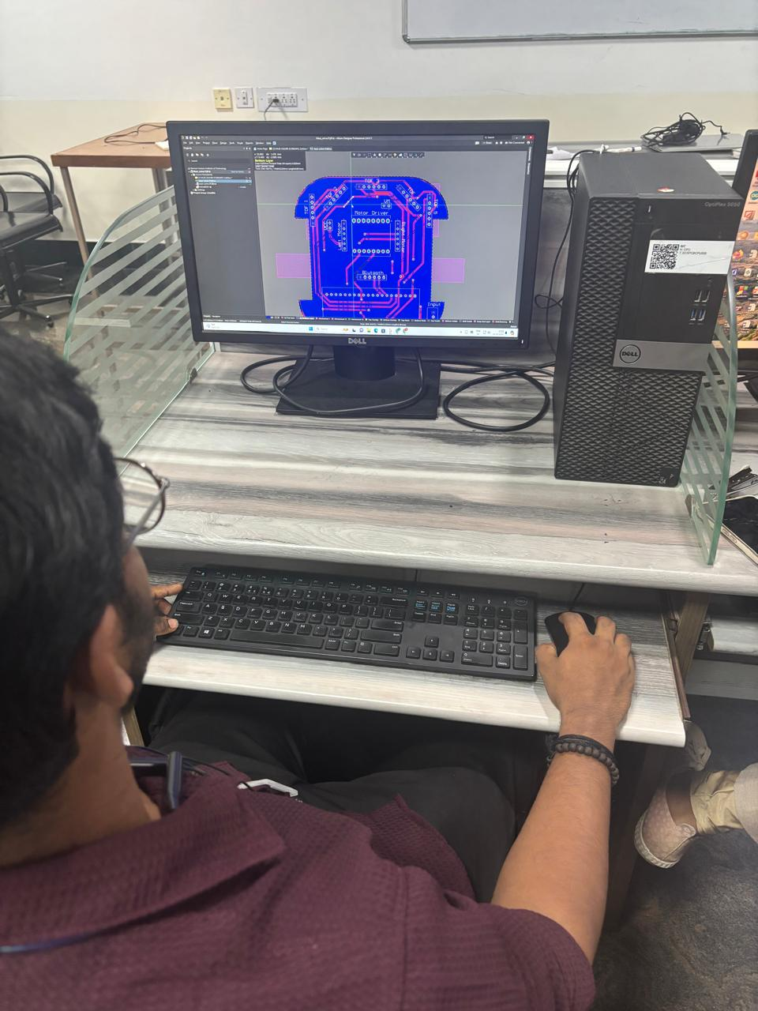
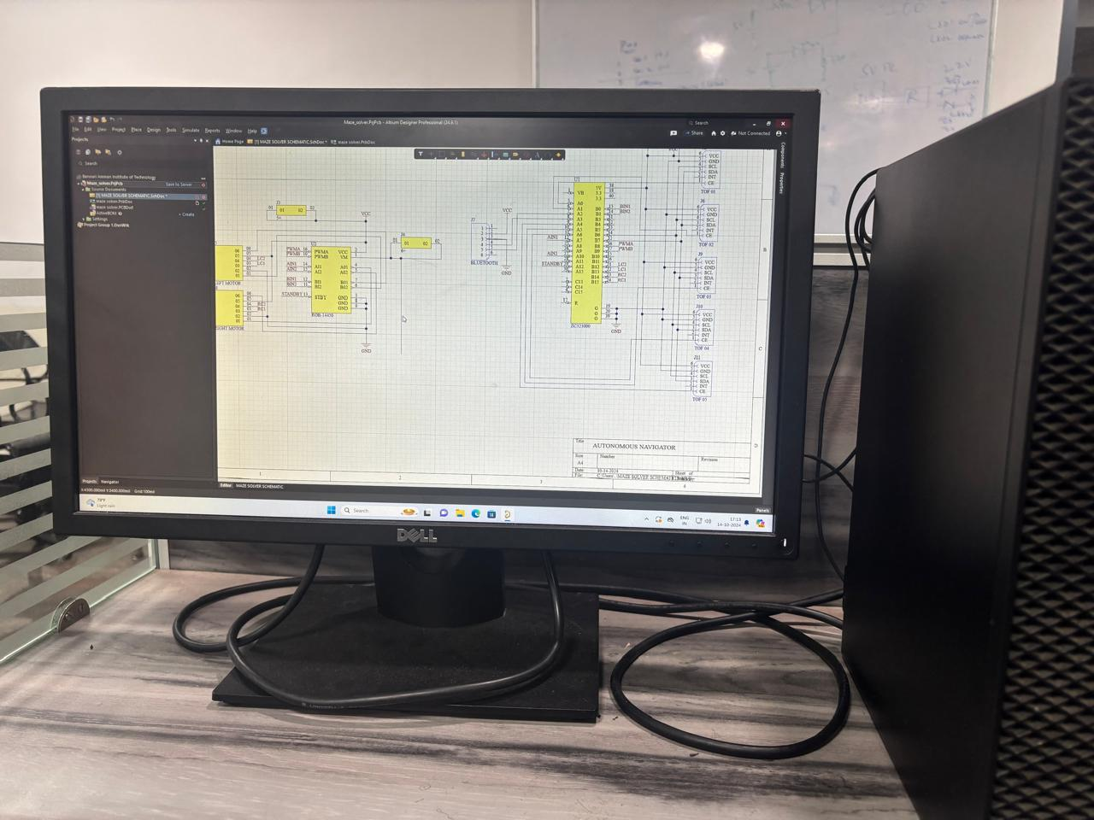
Figure 4.2 Schematic Design
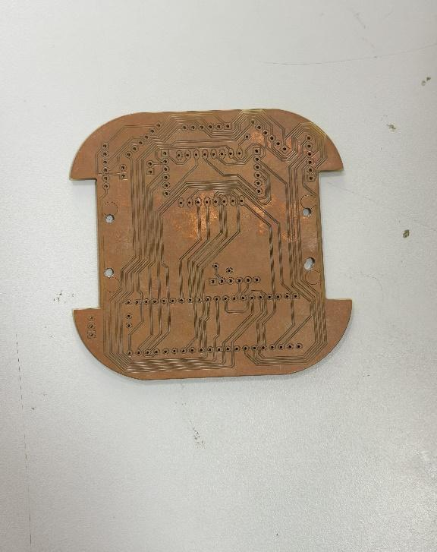
Figure 4.3 Layout Designing
Figure 4.4 Single Layer PCB
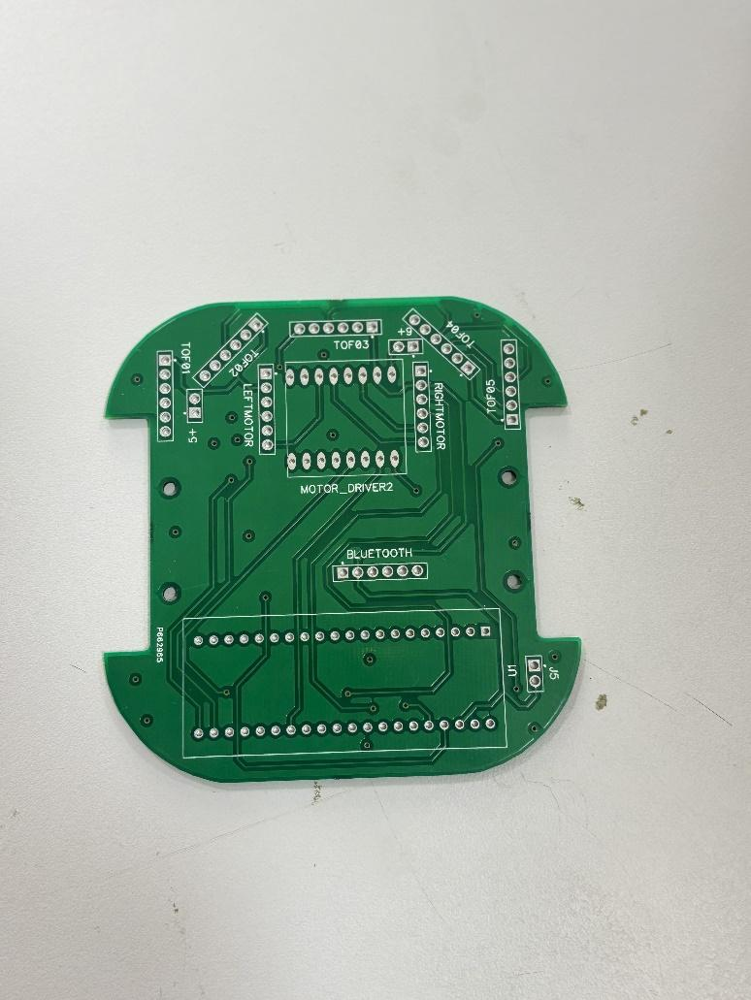
Figure 4.5 Double Layer PCB

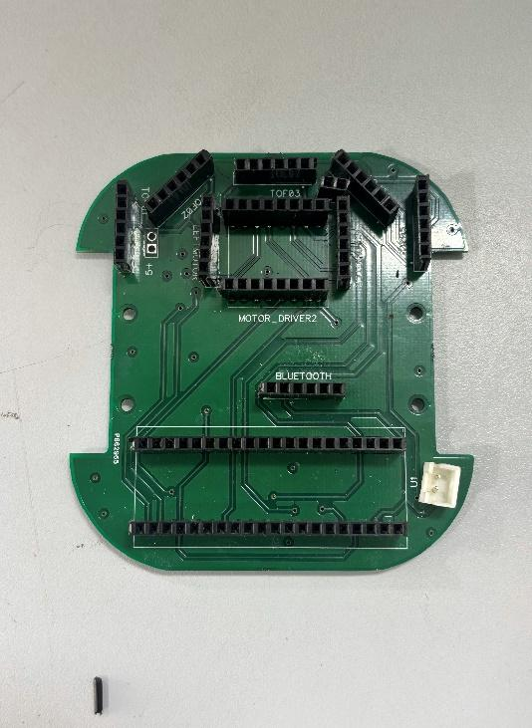
Figure 4.7 After Soldering PCB

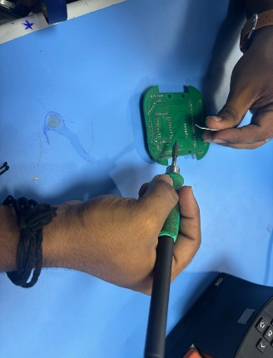
Figure 4.6 Soldering Double Layer PCB

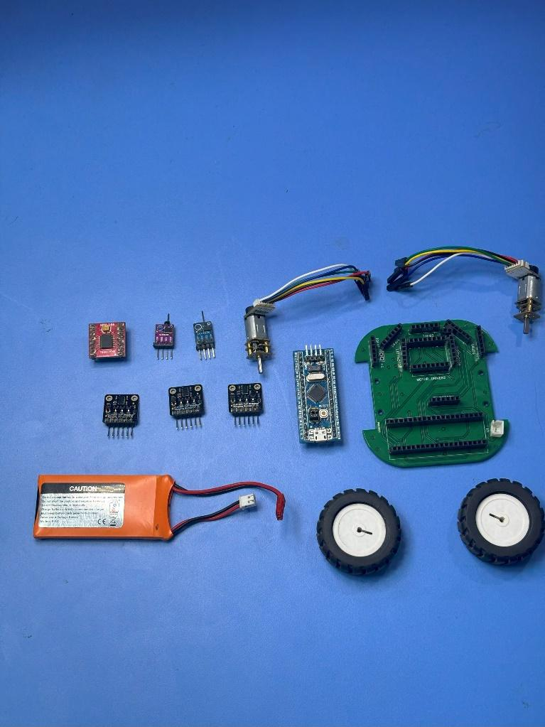
Figure 4.8 Components

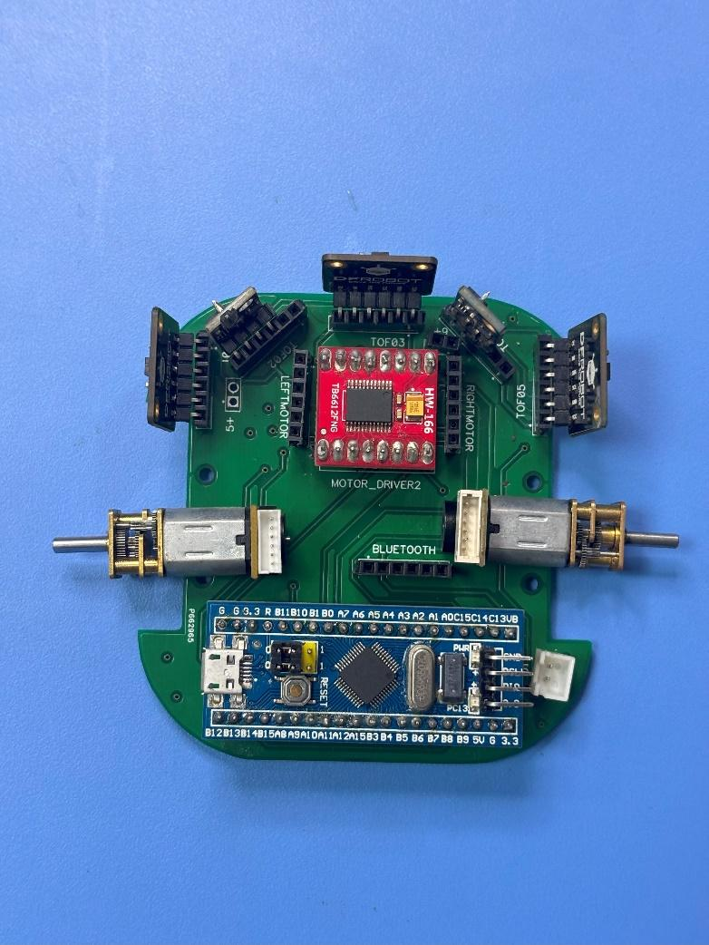
Figure 4.9 After placing components
(Top View)
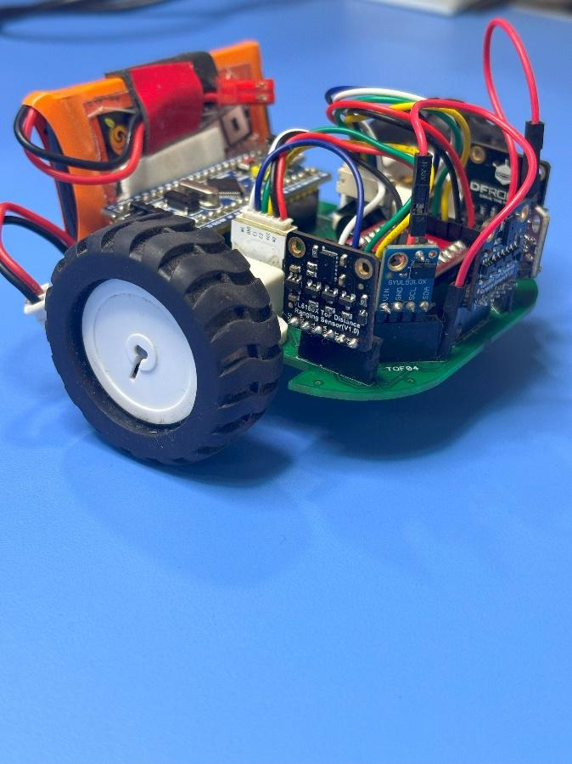
Figure 4.11 Bot Side View

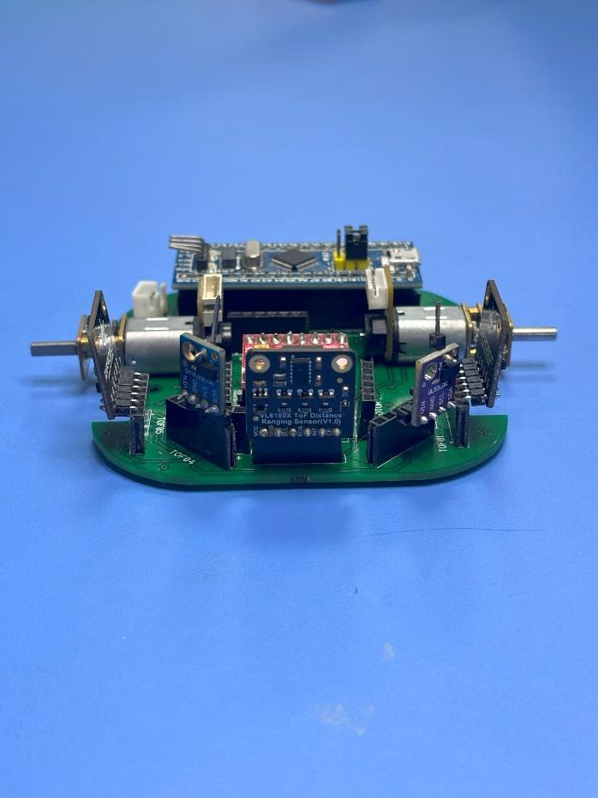
Figure 4.10 After placing components
(Front View)


Figure 4.12 Bot Top View

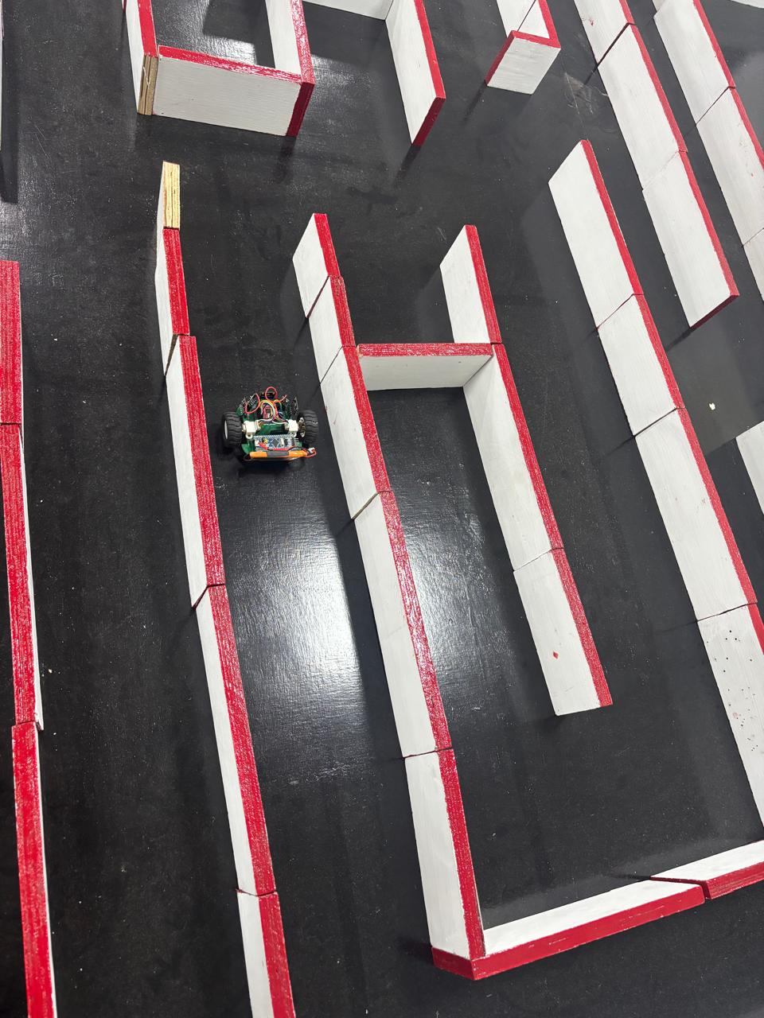

Figure 4.13 Bot Working in Maze

